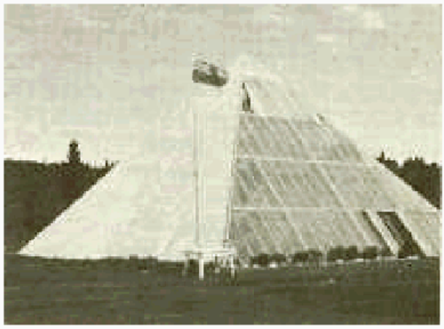

EDITOR'S NOTE: The author passed away in the 1990's and his work must carry on if humanity is to learn self-sufficiency.

It is known from applying heat-conveying properties of glass structures to the side of a building that an atrium or greenhouse heats the structure to which it is attached. So, we have appended a simple houseplan to this pyramid-structure concept-- as the base upon which a pyramid-type glass greenhouse will serve as 1) roof; 2) heat source; 3) garden-space food source 3) interior-light source and 4) oxygen-source.

It is for the reason that we have become an oxygen-deprived people that we must change the way we live and exist on the surface of the ground, or perish from weakness, pollution and from chemical intrusions.

TOTAL ECO-SYSTEM HOME
The PYRAMID, by Les Brown

Published in Bancroft, Ontario, Canada 1978 and here for Fair Use by Emily Cragg for abidemiracles and Holyconservancy, 2005 -2009

A RAY OF HOPE ON OUR PLUNDERED PLANET
Understand the Truth About Destruction of Earth's Atmosphere

INTRODUCTION TO THE CURRENT EDITION

The need to create a living biospace has never been greater. Cities are choked with bad, stale and rotting air. Grocery produce doesn't have the nutrients, the minerals, that healthy people need to live well. The pace of life for commuters is frantic and half-baked. Land is very expensive where work exists; and where land is cheap, there is no paying work for an educated soul--just drudge work, repetitive work, rule-based work.

If you buy this book, it's because you want freedom from the ratrace. Please note, however, what you are gaining here is the freedom to become responsible for yourself. This means, you're going to get busy, learn how to manage your debt until you get out of debt entirely and get on with living debt-free.

Yes, you'll get away from traffic, schedules and daytimers, but you'll have to remember to water your plants every day. Instead of living by the clock, like farmers back in time and forward to Eternity, you will live by the seasons, by the rain or lack of it, by tne temperature and air flow and humidity and effort of your own hands.

If you don't want to do that, just put this book away now. This book is about farming on the roof of your own home--1800 square feet of farming, a 30 foot by 60 foot garden plot within the protective covering in which you also live, eat, sleep and carry on. ... After all, people take pets into their homes that dirty things up and make messes on the floor, why not take plants into your home that product oxygen, food and beauty and don't chew on your slippers?

Now, think about this. Yeah, I suppose someone could build a pyramid home and use it for an art studio or day care center for older latchkey kids. Or, how about an orchid nursery? It'd be a great bird sanctuary or herpetarium. Yes, you could put a playroom on the main level, and garden plants only on upper levels so the kids would be out of your hair on dull, cold days.

This pyramid is too pretty to be used as an machine shop or wood shop. My, how to outrage the wife! She'd never forgive that--the guys upstairs where it's all light and beauty making their messes with welding torches and quenching pots, dropping hardware on the floor. No, I don't think so. But--you know--give it some thought. Anything's possible.

1. Chapter 1: Observations
2. Chapter 2: Why a Pyramid?
3. Chapter 3: The Source of Pyramid Energy
4. Chapter 4: How the Energy Affects Living Cells
5. Chapter 5: The use of Pyramids for Production
6. Chapter 6: Food Preservation
7. Chapter 7: How to Build a Pyramid
8. Chapter 8: The Myriad Uses of Pyramids
9. Appendix

INTRODUCTION

With the earth's wide open spaces, enormous expanses on which to grow food, seemingly limitless water and only [6.6 in 2004--ED.] billion people in existence, one person in every nine is starving to death. That many are literally dying from lack of food; they are not just hungry, as is an even greater percentage of the world's population.

How, then, can mankind possibly hope to feed [them]sel[ves] by the time there are sixteen people alive for every one here today? This is a dilemma which I hope to provide a means of solving with this book. It is a problem to which I am dedicating my life's work.

These are the figures which day by day have been growing steadily more stark within my mind. Every time I turn on the radio, read a newspaper, or watch a TV program, I see hammered home the fact that while I am well and satisfyingly fed, myriads of other people mostly in underdeveloped countries throughout the world, are suffering from the wormlike threadings of hunger pains in their bellies as they lie down to sleep at night.

Life on our world is powered by light. Light from the Sun, which passes through the clear air, is harvested by plants and powers them to combine carbon dioxide and water into carbohydrates and other foodstuffs, which in turn provide the staple diet of herbivorous animals and people.

Our planet is indivisible. In North America we breathe oxygen generated in the Brazilian rain forest. Acid rain from polluting industries in the American Midwest destroys Canadian forests. Radioactivity from a Soviet nuclear accident compromises the economy and culture of Lapland. The burning of coal in China warms Argentina. Diseases rapidly spread to the farthest reaches of the planet and require a global medical effort to be eradicated. And, of course, nuclear war imperils everyone. Like it or not, we humans are bound up with our fellows and with the other plants and animals all over the world. Our lives are intertwined.

If technology destroys the ability of the atmosphere to cleanse itself, then we are all doomed together--plants, animals and people. So, we need to rethink survival, when in fact our governments are dead set on powdering the atmosphere with poisonous aluminum and barium powders that result in oxidation of the ozone layer and depletion of atmospheric oxygen. We better get under the cover of glass and plants, or we'll be extinct, quickly.

This has grown to be a thought which constantly tortures me. For a long time I have wondered what could be done. Since childhood I have had the dream of growing food in greenhouses in some revolutionary fashion: more, better and bigger crops than have ever been grown. With this aim in view, seven years ago I bought myself a secluded farm in the country near Bancroft, Ontario, retired myself from the unbelievably busy life of a fashionable interior decorator in Toronto, and started planning for the monster greenhouses I intended to erect upon my farm. Three incidents sufficed to redirect my planning. First, I read a book, Chariots of the Gods, by Van Daniken in which he postulated the theory that in incredibly long-gone aeons extraterrestrial beings visited the earth--"gods"--and left part of their beings and of their intelligence as a legacy for the children they sired upon the aboriginal earth inhabitants with whom they cohabitated. Part of this legacy, it is postulated by some, may lie in the pyramids.

Secondly, after extensive and painstaking experiments with the pyramid, I proved to myself, as others have done, that the pyramid is a blessing in disguise, one that could possibly be the ultimate saving of manking as far as the growth and storage of food are concerned.

Lastly, I attended a lecture a few years ago in Peterborough, Ontario, Canada, sponsored by pyramid authorities Alfred Ward and Bruce Knapp. Alfred Ward operates a franchise for selling pyramid products manufactured by a firm in Glendale, California, and Bruce Knapp is an amateur pyramidologist residing in Peterborough, Ontario, Canada.

At the lecture I was astonished to hear my theories being spoken by Knapp. He too thought that the "gods," foreseeing the calamitous impasse to which mankind would one day bring [them]sel[ves] by [their] unbridled sexual appetites and lack of planning for the future, decided to give their earthling successors an idea as to how they could raise vast amounts of food in small spaces and, more importantly, how they could store that food by the use of pyramidal shapes.

This last incident was the impetus which finally turned my thoughts of conventional greenhouses, already dented by Von Deniken's book, towards pyramidal greenhouses, to be built of wood in exact proportion to the measurements of the Great Pyramid of Cheops at Giza in Egypt.

I felt that the pyramids of the world, brooding through the centuries, their ultimate secrets there to be seen but as yet unread by blind humanity, tourist attractions at best, were about to play their destined part in the "gods'" endeavor to save us from the reesults of our own folly. Humbly enough, I felt that maybe it was to be my part in the universal scheme of things to be the catalyst which would transform theory into fact, change pyramids from one of the wonders of the ancient world to one of the saviors of the modern.

Since nobody else seemed interested in trying the practical use of pyramids on a large scale for the growing the conservation of food, and since I had thought of it, it was obviously up to me to initiate steps which might possibly result in the children being born today having enough food to eat when they reached my age. Many people throughout the world were dabbling in experiments with pyramidal shapes. It has been shown, conclusively enough to satisfy me, that these shapes do have an effect upon plant growth. So why not combine my dream of monster greenhouses with the demonstrated ability of the pyramids to force plant growth? If the theories should not prove correct, only I would be the loser. If, on the other hand, as I strongly feel, the theories do hold water, mankind in general would be the beneficiary.

These were the thoughts, then, behind the erection of the first of my pyramids in 1974. This pyramid has been the subject of a number of TV and radio programs and of magazine and newspaper articles. Some of you who are reading these words may already be acquainted with my dream and its embryonic fulfillment. Insofar as is known, this is the first large-scale pyramid anywhere in the world for the express purpose of raising substantial crops.

I have done much research along the way and so far have brought to light several related and sometimes seemingly unrelated phenomena associated with the use of pyramids. Since I have no wish to stir up hornets' nests and arguments with the scientific professions, I am waiting until these phenomena are well enough documented for acceptance by the scientific community and will then release them through the usual channels.

One of my strongest wishes today is to encourage others to experiment with pyramids, for I am convinced that there are unbelievably wide horizons to be explored in this area, and only by countless people experimenting on their own will new uses of the pyramids come to light. One need not hold a doctorate in physics or any other scientific field in order to experiment; an inordinate curiosity and the ability to make a simple pyramidal shape are sufficient to launch one into unraveling some of the mysteries left hidden by the proposed extraterrestrial visitors of ancient times. To be of any value, however, the experiments must be meticulously documented. The day, the time, the weather, where the experiment is carried out, whether it is indoors or out, exactly what is done step by step, room or outside temperatures, or whether near to metals, electrical apparatus or wiring, metal fences or expanses of water are all factors which must be taken into account and recorded, anything that later may help you to draw useful conclusions about your results. Controls should be made, one subject under pyramid conditions being used simultaneously with one or more subjects under normal conditions.

In conducting pyramid experiments you should look daily for signs of change and note them meticulously, and above all be patient. Don't plant a seed one day and expect to have a plant six feet high the next. A plant takes just as long to develop inside a pyramid as it does outside, but in time you will see the tremendous difference in results, with respect to size. Also, don't keep moving plants around inside your the pyramid during an experiment; leave pots stationary so what you see is what you are getting.

In later pages this book will show you how to make your own pyramids for experimentation; they can be constructed entirely from inexpensive materials equally as well as from costly ones. Cardboard, wire, plywood or anything rigid enough to retain the pyramid shape will suffice. The pyramid does not necessarily have to be solid; in many experiments just the outline shape is sufficient, provided that it is jointed at all corners and at the apex.

Once you have made a discovery, record it on paper and put it into practice. Not only do you stand to gain a sense of achievement, but you might discover something of inestimable benefit to mankind in its titanic struggle for existence.

In addition to showing you how to build pyramids of all types, this book will also:

1. explore the source of pyramid energy;
2. discuss how that energy affects living cells;
3. look into the use of pyramids in food production;
4. discuss pyramids and food preservation;
5. discuss the many different uses of pyramids.
6. How to plan and execute an energizer to enliven any too-dormant part of your structure.

CHAPTER I

OBSERVATIONS

Over the past few years, since the first publicity on my pyramid in September 1974, I have had literally hundreds of requests for information on the subject of pyramids. It has become apparent that the only way I can accede to all these requests and still have time to pursue my aims with the pyramid is to write small monographs in expensive book form. These will get one started on building and using pyramids, and further discoveries will become the subjects of future books I am including in this book discoveries I have made as well as those made by friends and acquaintances across the North American continent and in other parts of the world. For the latter reports I thank the discoverers and wish to take no credit myself.

I myself see the pyramid as a symbolic sunburst of knowledge, with rays emanating from the center. Following any one of these rays one would learn who knows what, eacy ray being a new train of thought from a separate individual. Somewhere along the line, finally, all the rays would be incorporated into a circle in which they would all be interrelated. My own "thing" is the search for bigger, better and more bountiful crops with which to feed the growing hordes already beginning to crowd the earth beyond endurance.

We must prepare today for tomorrow. We must find new and unorthodox ways to produce nutrients, or possibly our children and for certain our grandchildren, will face a real and ghastly danger of ending up the image of the perambulating human skeletons we see so frequently on our TV screens, listlessly suffering and awaiting a miserable death. It makes me sick to see it. Mankind must realize [they are] faced with a friehtening snowball, this gargantuan increase in the number of human mouths to be fed. If it is a fact that we cannot feed our current population--and it is a fact--next year will be worse, and ten years from now will be unimaginable. How then will we be able to cope in 50 years? Even with the latest technical advances--hybridization, multi-

story greenhouses, fertilizers, automatic feeding and watering, artificial lighting--we are falling further and further behind in our bid to feed the world. If we do not come up with some solution--and soon--mankind seems doomed.

Politicians seem almost completely unperturbed, but then who ever heard of a hungry politician?! Wherever I look, inertia and disinterest seem to prevail in high places. This is why I have decided it is up to us ordinary people to take the initiative. If the men and women we pay and trust to shoulder these burdens refuse to assume them, we will just have to fend for ourselves.

It is my belief that the pyramid is the answer to current and future food shortages. Using pyramids, I sincerely believe that I can grow 36 times more and better plants in a given area than any farmer or market gardener can in the same area, using conventional methods.

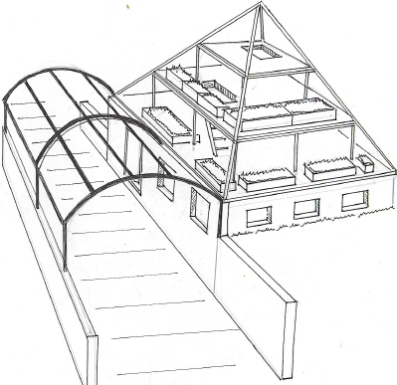

CHAPTER II

WHY A PYRAMID

The energy that keeps this world in balance and maintains its position in the universe, the energy that keeps us alive, and which is part and parcel of everything in this earth, is magnetic energy. The magnetic field is of a certain intensity, but since some objects qare more receptive to it, they are affected by the energy more than are other objects. Paradoxically, this inequality of energy attraction is precisely what keeps everything on earth in balance. Man's investigation of magnetic energy has allowed him to progress scientifically to his present-day standard of living. That investigation led to the development of electricity and the millions of machines, appliances, heating, lighting and power that it gives us. Without such progress we would not know what a car was; there would be no television, radio, telephone or computers. We would be living in a world as untouched as the day it dawned.

While such a world might seem highly desirable now, man nevertheless saw what he thought would better his life and he went after it. He realized that the magnetic force, if collected and condensed, would give him a force with which he could make inanimate objects move for him, and if he learned how to control it, the sky was the limit. But first he had to find a means of collecting and then boosting it to suit his purpose. So electricity was born. Man's progression since then is history.

That is, history as we know it. It is my theory, however, that long before man as we know him, from the Garden of Eden to the present day, was on this earth, there were beings of far greater intelligence in residence, who originated outside this earth. I believe they may have begun as we did and progressed similarly, often using their progress for the wrong purposes, seeking selfish gain for themselves as man so frequently does today.

I believe these beings became so advanced in their technology that they felt they could do without God. They felt they knew it all, their inventions made them wealthy, their wealth gave them power, and once that power developed, they believed they were masters of their own destiny. They felt they no longer needed God's help, and as a result were destroyed. Only those who lived in God's image survived. With His guidance they resided on earth and used their advanced technology to benefit mankind.

I believe these beings eventually escaped with their knowledge back to where they had come from originally and, as evidenced by the numerous present-day UFO sightings, I believe they have been watching mankind progress along a similar path toward destruction as did their own predecessors. They are warning us through psychics to change our ways before it is too late. In this modern age of greater acceptance of psychic phenomena, I suggest we heed such warnings, particularly those of such noted psychics as Edgar Cayce. History has always repeated itself, but now we have a chance to break the repetition, if only we will listen. I believe these people of long ago were Atlantians and that they will return in the not-too-distant future.

Not only are psychics trying to pass on the warnings of these people, but the Atlantians also left us, centuries ago, the Pyramid Cheops, also known as the Great Pyramid. Their purported technology would have been the only such advanced technology in existence at the time, capable of building such structures as the pyramids. Even today's engineers admit that we could not duplicate the Pyramid Cheops with present technology. My belief is that the Great Pyramid embodies pure truth and we will only survive if we use truth as our basic principle. Those who do not will perish just as the majority of Atlantians did before us. The Great Pyramid is a giant computer, built in the past to contain our future. It is a great receiver and transmitter with tremendous power, far beyond present-day man's imagination, and in its beautiful lines it contains the solutions to most of man's problems, plus the most important content of all, teachings akin to those of the Bible, showing man how to live in peace and harmony. I feel very fortunate in being allowed to show you some of the Great Pyramid's teachings, its benefits, and its performance.

This book is only elementary in that its purpose is to introduce you to the basics of the study of the pyramids. My next book will take you through a progression of fields of which you may only dream. From my experiments and research I possess knowledge about the pyramids that I will impart in future writings. Such knowledge is far too much for you to accept until you understand something about the basics. That is the background I hope this basic book will give you.

Before we can discuss energy, we first must construct something with which to collect it. All kinds of shapes; contain energy, even the materials these shapes are formed with, and the very nature of the shapes themselves determines the degree of energy they contain, that is, the shape determines receptability to energy. By shapes I refer mainly to cubes, spheres, triangles, pyramids and such. Each shape has potential, but they all have different limits. Whatever we do in our everyday lives, we strive for the best. So it is with shapes and the energy they contain; we should seek the one that offers the most potential.

Of all shapes, the pyramid will give us the best performance because it is receptacle to the greatest amount of energy. It must be four-sided, of specific measurements and correct angles, and must be correctly oriented. Where do we look for this specific data? We know that the Great Pyramid Cheops at Giza in Egypt performs well today, but

undoubtedly nothing like it did when it was complete with smooth surface and capstone. It is now known that upon completion the Great Pyramid included a capstone and covering of seven feet of white limestone alabaster. This material, which helped the pyramid function at its fullest, subsequently was robbed from the pyramid for use as building material. Even without it, however, we can measure Cheops, as many have, and come up with enough data to work with, but one must go further than the measurements themselves to understand why these measurements have such meaning.

We must go back to the time when a much higher intelligence than ours had a pyramid on the drawing board. The pyramid was not built for its looks, or by accident or coincidence, and it did not simply start to perform to the Atlantians' amazement. Instead, it was built because they knew beforehand that it would do all of that for which they planned it. In my research of the pyramid I have gone beyond where your wildest dreams might take you; but for the present will stick to basics, taking you step by step, showing you what the pyramid does and why and how it works, so that you will be able to follow up my studies in a safe and sensible progression. The word safe may sound a little ominous, and well it should because there are dangers in using the pyramid blindly without knowledge of its functions and its great potential.

Having set the stage, let's get to the pyramid itself. The pyramid is built with straight lines of specific length and orientation. This is how we arrive at the line proportions. (See Fig. 1.) Imagine cutting the world in half at the equator (try this with an orange), taking the top half and cutting it into four quarters or quadrants, then taking one of these quarters and taking the peel off. Flatten out the peel and you will have a triangle with curved sides; trim the curve off without taking anything off the length and you will end up with one face side of a perfect pyramid.
(NOTE: If you constructed each triangle as the cone-shape without squaring the bottom, energy yield as a direct-current battery would become dangerous to life unless it was tapped off and used. --Ed.)

Having squared each triangle, put all four triangular shape pieces of peel together and you have transformed the northern hemisphere into a pyramid. The bottom corners of the base fit perfectly into the circle of the equator, and the sides lead up to its North Pole.

Using these proportions, any pyramid will function in unison with the natural elements that we enjoy, the natural elements that keep us alive and the world in balance. Change this ratio of measurement and you will drop below par in performance. The further you deviate from this formula the less performance you will get. Of course, we cannot build a pyramid as large as the northern hemisphere, but whatever size is built, if built in correct ration to the Great Pyramid of Cheops, it will give 100 percent performance.

I will not go into all the details of the Great cheops, but will mention a few, just to illustrate that this ratio was strictly adhered to, plus a few more items which indicate that it is not just a beautiful structure, but was planned for a purpose. Cheops covers approximately 13.1 acres and is square at the base, as we shall see it must be. It has been measured throughout the centuries by many brilliant men, using cubits, metrics and inches, and after years of controversy as to whose measurements were right, the consensus of opinion accepted inches as being nearest to the correct measurement. The distance around the base of Cheops is 36,524.24 inches, which coincides remarkably with the 365.24 days of our lunar year. If we add together the diagonals of the Great Pyramid's base, we find the sum to be 25,827 inches, a figure which also represents the number of years in the precession of the equinox.

The pyramid has five points and four sides plus a base. The line extending from the point where it would touch the Equator up to the North Pole (base side corner to peak), leans in at 51 degrees, 51 minutes, 14 seconds. Since this book was intended to simplify matters so that you can conduct pyramid studies with ease, here is a simple way to figure out a perfectly proportioned pyramid of any size (See Figure 2.) Predetermine the length of one side of your base (A).

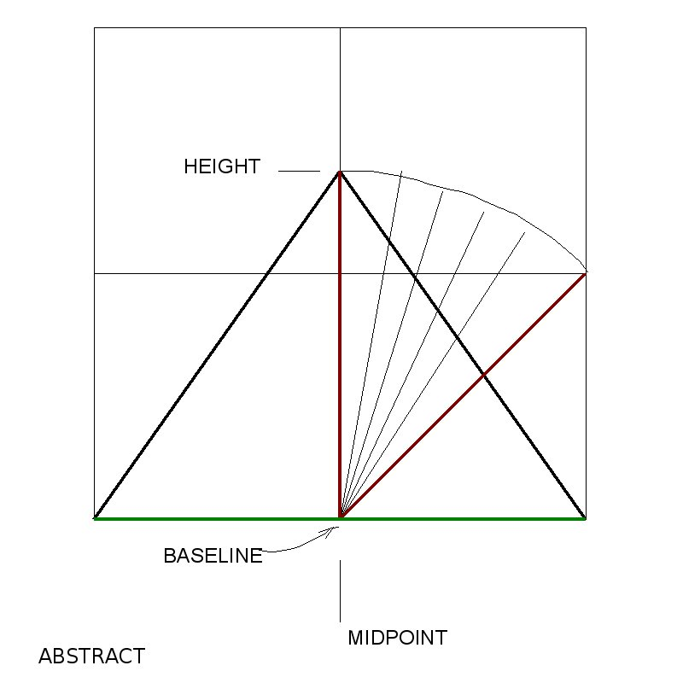

Now on paper, draw a square to your base, then divide it into four quarters. Now, draw a diagonal (B) down one of the small squares and measure it. Mark that measurement from the base up the center line (C). This will be the length of the apothem, that is, the length of the center line down one of the sloping sides of the pyramid. Finish off the triangle by drawing two lines (D) and (E), each running from the top of the mark you have made on the center line (C) down to a bottom corner of your base. By measuring these lines you now have the length of the side edges of your pyramid, and you already know the base measurement.

When you look at the triangle you have just drawn, it may look too tall, but don't forget that it has to lean in to join with the other three sides. When all four sides are put together you will have a pyramid the right height and leaning in at 51 degrees, 51 minutes, 14 seconds.

This method can be used for any size pyramid, whether it is two inches along its base or 46'1-1/4". There are other methods of constructing a perfect pyramid, but this is the easiest. Let's assume that you have not built your pyramid, and we'll talk about the energy. I personally believe that the answer to the puzzle of the pyramid's energy is right under our noses, but that scientists are looking beyond the obvious.

Until recently, comparatively speaking, it was assumed that the historically ancient Egyptians built the pyramids at the orders of their kings as mausoleums for the latter. This theory has been proven false by the fact that, so far as I know, no traces of any mummified human remains have actually been reported as having been found in any pyramid. It is highly questionable too whether primitive men, using bronze picks, wooden rollers and ropes, could possibly have erected these gargantuan edifices which modern civil engineers have declared would be almost impossible to construct even with the most advanced technical methods of today. Why then should the extraterrestrial beings have decided upon such a task, and how did they accomplish it?

As to the how, ancient Egyptian hieroglyphics depict many devices which are recognizable as types of technological equipment in use today. Electric generators, electric bulbs, etc. However, there are others, obviously tools, for which no counterpart exists today and about which we can only conjecture. Possibly, even probably, they were devices which were used for such tasks as cutting, transporting and lifting the gigantic blocks of stone with which the pyramids were built. These blocks range from two to 70 tons in weight. The work forces, the laborers, were probably the aboriginal inhabitants the extraterrestrial beings met on earth, educated in the use of the building implements by the superbeings who were the designers of the pyramids (10,500 years ago--Ed.).

As to the why, it is certain that there were many reasons behind the building of these unique edifices: landmarks, aerial beacons, trig points for cartographers, storage structures or temples, but more than anything else, for power of one sort or another. Each day gives birth to some new conception of the intended use of the pyramids.

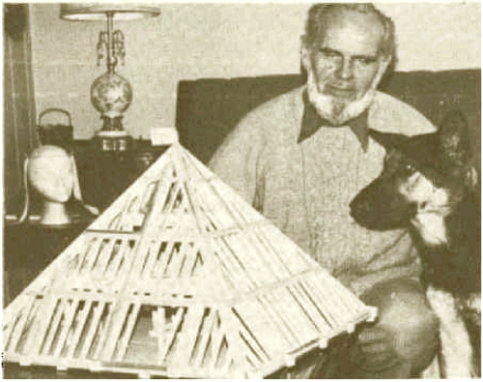

CHAPTER III

THE SOURCE OF PYRAMID ENERGIES

In the preceding chapters I have mentioned pyramid energy. Of what does this energy consist? Whence does it come? Although I have no college degrees, I have an extensive education in practical experience. I have a practical and inquiring mind and have bent myself to searching for some kind of answer to these questions. The answers I have amassed are based on much research of my own particular brand, called performance. When you get exactly the same results with man-produced energy as you do with a pyramid, then you can say that at least here is one of the energies of the pyramid. I say one because there is more than one type of energy involved in the pyramid, but the main type is magnetic energy.

My theory is at least as good any anybody else's; for insofar as I am aware no one has been able to prove in a scientific manner what the energy undoubtedly generated by a pyramid consists of. There has been talk of biocosmic rays, cosmic rays and other esoteric forces, but the plain truth is that nobody knows for sure just what happens inside the pyramid. Because of the experiments I have done and the results I have obtained, both successes and failures. I have abundant evidence to back up what I am about to say. I can prove conclusively that the pyramid receives and collects magnetic energy from the poles, cosmic rays, which is radiation coming in from all angles in equal strengths, and radio waves. There is enough information on these three energy forms to fill another book, but that would be far too advanced for the beginner.

The first two energies mentioned, magnetic and cosmic rays, enter the pyramid through the peak; radio waves enter through the sides. Since these energies come from many angles, there is a curling that takes place as they are absorbed, and some reports I have read state that the energy swirls clockwise on a sunny day and counterclockwise on a dull day or at night. I personally can find no reason for it to change direction according to light, nor do I recognize this in my experiments. However, of importance is that it does collect down through the peak and continues coming in until it reaches a certain intensity, or the limits of safety, at which point the pyramid releases all the energy and begins collecting it again. Kirlian photographs taken of pyramid generators show this energy, invisible to the naked eye, being released in jets up through the apexes of the pyramids. The pyramid is said to release 80% of its energy through the peak and the other 20% via the four base corners (See Figure 3).
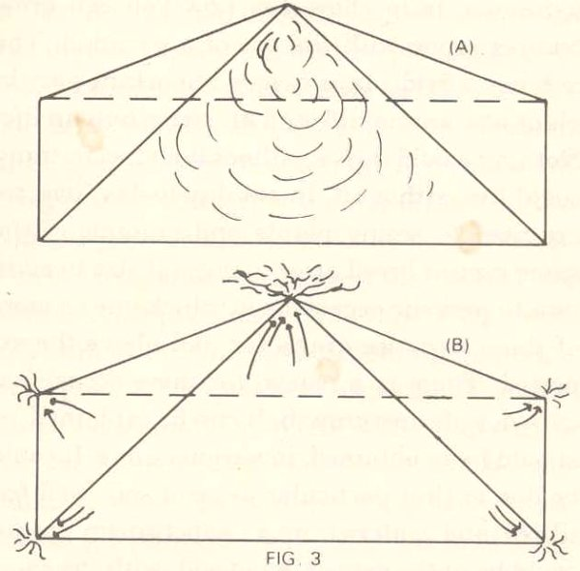

Only a pyramid will perform this way, and even then the maximum performance is obtained only by a perfect pyramid. So, when you start to build one, aim at perfection. The nearer you can get to a perfect pyramid, the more you will benefit.

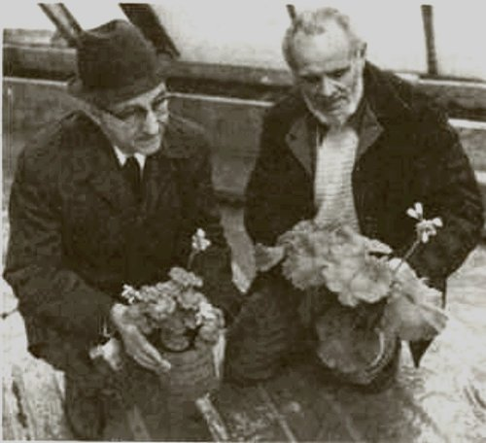

CHAPTER IV

HOW ENERGIES AFFECT LIVING CELLS

The main purpose of this small book, in addition to acquainting you with the basics of the pyramids, is to show you how you can grow bumper crops with the use of a pyramid. The magnetic field plays a very important part in plant life, animal life and of course human life. Nothing would thrive without it, in fact nothing could live without it. In our day-to-day lives we are used to seeing plants and animals of the same type or breed grow to normal size in addition to periodic occasions in which one or more of these varieties grows far and above the expected. There is a reason for these occasional episodes of supergrowth. It can be explained, or should I say, in various ways. It could be due to that particular piece of soil, well fertilized and watered, or a "supergrown" plant could be in the same kind of soil, with the same conditions, as those plants growing normally, but positioned perhaps near a metal fence. In nearly every instance, anything growing by an iron fence will be bigger and better than one nowhere near metal. The reason is that the iron fence picks up static or magnetic energy and feeds it to the plant.

I remember my mother and grandmother placing large nails in the soil of their potted house plants because plants thus treated always grew bigger and better. They had no idea why. In fact, if you asked them, the standard answer was that, as the nail rusted, the plant fed on it. This reasoning is fallible, however, because for one thing, plants can only absorb minerals in liquid form and for another, the rust would kill some plants. Rather, the nails picked up the magnetic energy and boosted the house plants' growth. I suppose you can see that what I am driving at is that when a plant receives an extra dose of energy to that already floating free in the atmosphere, that dose acts as a stimulant and causes better growth. What really happens is that the living cells are increased in size, and naturally when each cell is larger, since there are still the

same number of cells, the final plant is a lot larger than normal. To illustrate, if I fill a basin half full of dried peas and fill it up with water, by the time the peas have completely soaked they fill the basin. There are still the same number of peas, but there appear to be many more.

Similarly, if you plant a plant in a pyramid, the same sort of thing happens, but there is a difference. As detailed earlier, the pyramid collects magnetic energy and absorbs it to a higher intensity than the nails in the plant pots did, a much greater intensity or strength, and so the end result is, you can expect enormous growth, and when this is applied to vegetables and fruits, the plants, as well as their products, are immensely oversized. My own experiments have convinced me that this energy creates a special reaction in living cells of plants, resulting in larger blooms, leaves and fruits on whatever plants are propagated within the pyramidal shape.

The normal life cycle of lettuce, for instance, from seed to maturity, is six to eight weeks. Grown under a pyramid the life cycle is still the same, but the plant is considerably larger. If one allows the vine type of tomato to mature to six or seven trusses under a pyramid while simultaneously allowing an identical plant to do the same outside the pyramid, giving both plants precisely the same feeding and watering, a startling difference in yield occurs. I should mention that if you put your outside plant too near the pyramid, it will reach for, and receive, some of the pyramid's energy, so keep it well away to get a fair test. The outside tomatoes would weigh out at approximately 10 to 14 pounds per plant, whereas the plant grown in the energy of the pyramid would produce between 50 and 60 pounds of tomatoes. Not every type of plant grown under a pyramid will produce this increase; this is the average that I have come to expect from tomatoes.

A few more averages I have obtained repeatedly were: lettuce two to three times larger than average; beans 25 inches long by 1-1/4 inches wide; cabbage--when controls were three pounds each, the pyramid-
grown plants were 12 to 13 pounds per head; radishes that normally would be the size of a quarter were four inches in diameter; controlled

cucumbers that averaged 14 inches in length and weighed up to one
pound normally, were 21 inches long and weighed up to four pounds when grown in the pyramid.

A few more averages I have obtained repeatedly were: Lettuce two to three times larger than average; beans 25 inches long by 1-1/4 inches wide; cabbage-- when controls were three pounds each, the pyramid-grown plants were 12 to 13 pounds per head; radishes that normally would be the size of a quarter were four inches in diameter; controlled cucumbers that averaged 14 inches in legnth and weighed up to one pound normally, were 21 inches long and weighed up to four pounds when grown in the pyramid that warms your whole house and cleanses the air you breathe.

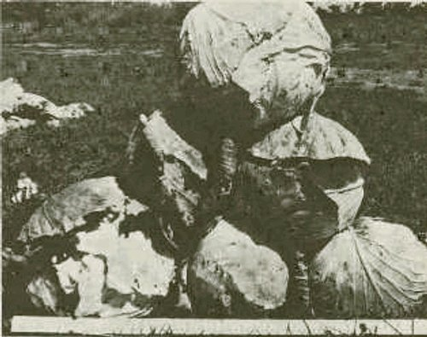

Energized air in the pyramid also appears inimical to small insects; thus, there is no need for pesticides to be used within its glass walls. Pest-free plants grow to maturity inside, with none of the setbacks plants subject to normal attack from pests suffer in the garden outside. This also means that pyramid-grown vegetables need no washing upon harvesting. The mere appearance of such plants is more appetizing than that of those grown normally. Greens are more vivid, and many leaves have a sheen which is noticeably absent from plants in kitchen gardens. Artificial fertilizers will never be used in my pyramid. Since many fertilizers apparently are becoming short in supply themselves, the ability to grow plants without their use is a double blessing for all mankind. I will use natural farmyard manures, the best way to regain succulent taste and nutrition that are missing for too long in engineered and chemicalized food.

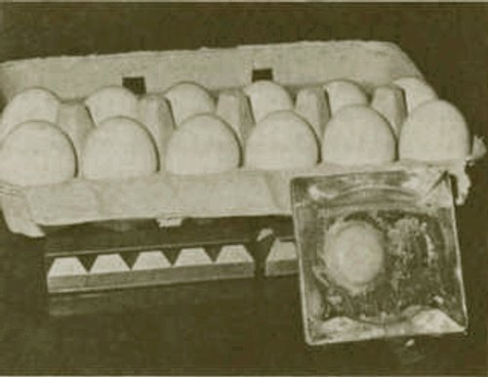

An egg broken out of its shell and left within the confines of the pyramid will gradually congeal and become like plastic, as the interior energy works on its cells--harmlessly. The cells do not die nor induce putrefaction. After a period of even weeks or months these congealed

eggs can be reconstituted in water to the point where they can be eaten
with complete safety--and taste even more delicious than eggs produced in the usual ways.

BTW, one peculiar phenomenon I have observed under my large pyramid is the formation of dew upon plants inside, early in the morning. During all my years of experience with greenhouses I never noticed dew forming on any plants in conventional greenhouses. This dew gently dissipates as the sun grows stronger, exactly as it would outside. Also, after a recent thunderstorm, my pyramid cucumbers grew two to two and a half inches in a matter of a few hours.

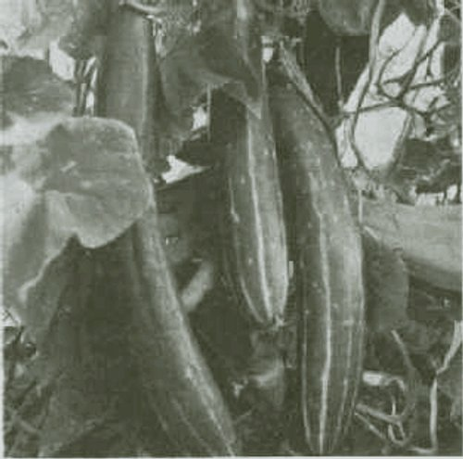

CHAPTER V

THE USE OF PYRAMIDS FOR PRODUCTION

The pyramid reproduced on the front of this book is my prototype for larger ones. This one was purely for research and would need to be much greater in size for production on a large scale. In tuilding the prototype I encountered and overcame virtually all the problems one can expect to meet in this type of construction. It is nothing like building a house, and whereas a slight difference in measurements can be overcome in a house, it is not possible to make a mistake in a pyramid and carry on building. The particular piece containing the error must be pulled out and replaced correctly, as any mistake is transferred all the way around the pyramid.

This test model is 30 feet high along a perpendicular line from ground to peak. The sides from base corner to peak are 44 feet 4-1/2 inches, with a baseline of 46 feet 10-1/2 inches. It contains two additional floors above ground, and the sum of the areas of these two floors equals or is greater than that of the ground floor. Thus, the two additional floors virtually double the growing area. My first floor is 12 feet from the ground, and there is a reason for this. I calculated that when the sun was at its highest point the first floor would have to be positioned at a 12-foot height to allow the sun to shine onto the back north edge of the ground floor. The 12-foot height was perfect, its achievement resulting from a mixture of good judgment and a bit of luck. However, I would not need to build a growing level at this height again because there are as many plants that grow well in shade as there are those that favor the sun. In the future my floors will all be eight feet apart, and I will put my sun-loving plants in the southern half and my shade-loving ones in the back northern half.

By placing the floors at eight-foot intervals there is much more growing area available than there is in placing the first floor at a 12-foot height. In addition, utilizing this lower height allows upper floors to decrease more slowly in size than they would if placed farther apart, for as the peak of the pyramid is approached, the floors decrease in area at each progression. One of the benefits obtained with these extra floors is that since heat rises, there are higher temperatures on each floor toward the top of the pyramid. This allows a wide range of crops to be grown.

To illustrate the temperature differential, if the ground floor were 75 degrees Fahrenheit, the second floor would be 90 degrees, and the third floor would be around 105 to 115 degrees, each floor carrying more humidity. This means that anything from cool to tropical crops can be grown within one pyramid. The ground floor is perfect for such crops as radishes, lettuce, carrots, beets, tomatoes, etc., while the second floor is ideal for cucumbers, squash, peppers, and plants that like it hotter and more humid than the first floor. Of course, the top floor can be used for lemons, oranges, figs and especially, orchids.

The pyramid draws in its own water on the ground floor; I have never had to water that level [because his is built directly on the ground--ED]. It never draws too much or too little water, just the right amount for growth. Naturally, I have to pump water to the upper floors, but because the first floor provides its own water supply, at least half of my pyramid is watered for nothing automatically. I grow right in the ground the pyramid stands on, but upstairs I have placed wooden planting troughs all around the floors, leaving room to walk, and I grow plants in these. It is a major job getting the soil to the upper floors initially, but it is only a one-time task. The troughs are 16 inches high and 14 inches wide, and contain a bottom. There is a run all around the edge of each of the upper floors and another inside, leaving enough room to work, with a gap on each side allowing passage from one run to the other.

Space in the pyramid is utilized to the utmost. In the low areas at the perimeter I plant the kind of plants that need little headroom, and then plant bigger crops toward the middle. It is a matter of common sense. But using vine type tomatoes and stringing them up, one can work between the rows better, and if the lower leaves are removed, there is sufficient space to grow lettuce, cabbage or any low-lying crop in between the tomato plants. The trusses may be left on the tomatoes; they will not shade the low-lying plants. To ensure a steady supply of food, it

is wise to plant only a few plants of each variety at intervals, which means that in the beginning it will take several weeks to reap a full harvest, but subsequently there will be a continuous yield.

By planting in such a manner, the grower will realize the equivalent of approximately six full crops a year. This method applies only to an enclosed pyramid, which would also require heating in the winter. The means of heating is up to the individual. I personally use a wood stove because I have my own wood supply. A wood and oil combination is best because it allows one to take off for a couple of days if necessary. If the wood fire gets low, then the oil burner takes over.

As for growing potentials of the floors of the pyramid, I have found that the second floor is the best place for germinating new seeds. I find that I can get germination in three days on that floor, whereas it usually takes five days otherwise.

Thus far I have described the pyramid from the growing aspect only to the point of showing you how and where to grow crops, but let's take a look at a few statistics on production. Your garden, for instance, will only give one crop a year, but the pyramid through the means I suggest will give you six crops per year. Now let's compare two pieces of ground, both the same size, one with a pyramid on it. Say the garden is 50 feet square and the pyramid is 50 feet square. The upper floors inside the pyramid give you approximately 2,500 square feet of growing area upstairs to go along with your ground floor area of 2,500 square feet, and you are getting six crops per floor as opposed to one, or twice times six, the equivalent of 12 times your garden yield.

Nor is that all of the advantage. Recall from the previous chapter my discussion of the increase in size of the plant cells; this itself gives an average of three times the size of a normal crop. Multiplying the 12 times by the size of the crop, you are 36 times better off than with a single garden. [Keeping the soil mulched, enriched and well- drained naturally is more of an issue in a pyramid, than a once-a-year garden presents. --ED]

Now you see why I use a pyramid. If we can produce crops at this rate, it means that the ballooning population of the world could double a few times and still be fed better than it is today. This would improve the situation at present and give upcoming generations some breathing space during which mankind possibly could devise something even more efficient to deal with the food supply problem.

Proper utilization of pyramids, however, depends upon massive implementation of this paradigm. One man, or even a few hundred, will not even begin to scratch the surface of the problem. I am just trying to point out what I sincerely feel will be a successful way in the hope that many of my fellow men will follow suit and give a lead to the rest of this lethargic world.

There will be a side benefit to the production of larger crops that should do all of us some good. Increased yield by the use of the same area of land afforded by my pyramid will enable the cost of crops to be reduced drastically, perhaps by as much as 50 percent.

I have publicly committed myself in the media to trying to promote my ideas, for I feel it is time and beyond, that someone try to cut the cost of food and give ordinary people a break, especially our senior citizens. I believe, and so do many individuals who think as I do, that it is possible to both increase crops and simultaneously decrease costs. If by any chance I am proven wrong, at least I shall have the consolation of knowing I tried.

CHAPTER VI

FOOD PRESERVATION

In addition to food growth, the pyramid also has application in food preservation. I have read statistics stating that 40 percent of all food grown in my home country of Canada is lost to putrefaction, whether at the place of storage, in transport, in wholesale and retail, or finally in the home. If this happens all over the world, no wonder so many people are dying of starvation, and even closer to home, we find ourselves paying higher and higher prices for what does reach us.

These figures mean that either our methods of storage are highly inefficient or someone in authority couldn't care less. Regardless of how this spoilage occurs, however, the state of affairs can and must be remedied; it is both ridiculous and criminal to let it continue. Even though I have told how--as well as shown and proven how--to use the pyramids to solve the problem, on radio and television and in newspapers, no one in any governmental department has even picked up the phone to inquire about it. It seems that the words "govern" and "mental" don't work together.

Energy of the pyramid that grows plants so amazingly well can be used also for the purpose of mummification of food, which can be dehydrated and kept in storage for an indefinite period without losing any of its taste or nutritional properties. There are absolutely no ill effects on any food stored in a pyramid. In fact, in many instances it is far better when reconstituted than it was in the first place. It has the water taken out of it; but it also repels bacteria and as a result, nothing will rot in a pyramid. For instance, I cannot make a compost heap inside my pyramid; I have to do it outside; otherwise the ingredients in the compost all remain in good shape and will not break down. For further proof, the grain grown in Manitoba today is a direct descendant of the grain found in the Great Pyramid, grain that had been there for centuries

an had kept perfectly. The government knows this but still bemoans the amount of grain lost to putrefaction in granaries. It makes me wonder at the mentality of the people we elect to look after our affairs. Naturally, since I am Canadian, I am referring to what is happening in Canada; it is probably happening elsewhere too.

Earlier I mentioned mummifying eggs. I conducted an experiment in mummifying an egg, using a pyramid energizer instead of a single wire pyramid. The energizer consisted of a small batch of one-inch-high pyramids, 20 in all, positioned in a group.

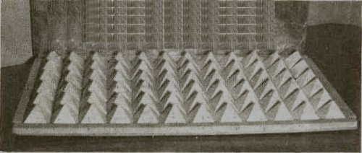

Using such a grid of pyramids provides quicker results than using just one pyramid. I broke an egg into a dish, placed the dish on top of the energizer and observed what happened in the ensuing days. In about six hours I noticed the lower perimeter of the yolk turning a pale yellow, and this continued through each day, the pale color gradually moving up to the top of the yolk. In the meantime, the white was becoming less fluid, thickening, so to speak. In two weeks the whole egg was just like glass; the yolk was hard and the white was now in crystal form. At no time would flies or any insect approach it, even though it was open to them. Flies were as prevalent as usually, but they would not go near the egg. There was never any smell present from start to finish.

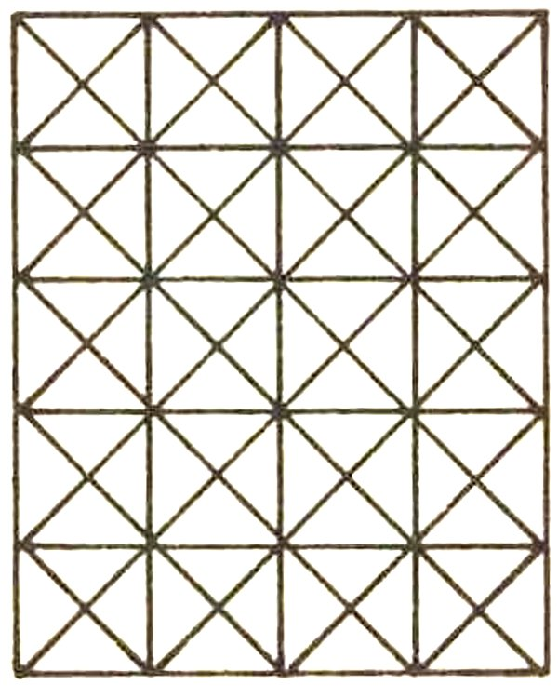

I left the egg in this state for about three months and showed it to many of my visitors, but then it was time to reconstitute it and try it for taste. I added some water (an egg loses about 30 grams of water in such a period) and left it 24 hours. I then boiled some water with the intention of poaching the egg. When the water was ready, I tipped the egg in, and immediately the albumen turned snowy white and the yolk a perfectly natural yellow color. Had I dropped the egg before reconstituting it, it would have shattered, but now it was simmering away, looking just like an egg fresh from the pen. After cooking the egg I put it on a plate, salted and peppered it, then cut the yolk through with my knife, and it flooded across my plate. I admit I was not in too big a hurry to eat it, but if I was going to prove something, I had to taste it. I smelled the egg, and it was no different from normal, so I ate it. I can honestly say it was one of the nicest eggs I have ever tasted; it seemed to have more flavor than usual.

Had this method or one like it been used a few months back on a large scale the hungry world might have benefited from the saving of millions of eggs that went rotten in storage. We could have obviated the sorry spectacle which has come to be known as "Whalen's Waste." I know we cannot break all the eggs we produce for storage into dishes and preserve them in this manner; however, they may be preserved even in their shells, which is the way they could be preserved in the millions. I do not know of any food that cannot be treated in such a manner. I have tried preserving every food I can think of, and it all keeps indefinitely, with no refrigeration necessary.

Such a means of preservation by the use of the pyramid is better and cheaper, with no losses, so how can it be ignored? As I said before, nobody is listening, but the voices of my readers may help me in what I am doing. I firmly believe that food processing companies could save themselves billions of dollars by using pyramids such as mine, which in turn could mean at least a lowering of prices. Should they wish to cooperate, I am quite willing to place my knowledge at their disposal. [Les died before that happened.--ED]

CHAPTER VII

HOW TO BUILD YOUR PYRAMID

Since publicity was first given to my large, wooden pyramid some three years ago, I have been inundated with letters, phone calls and personal visits. People from all walks of life and many different places in North America and Europe and indeed a few from further afield--Australia, Africa and the East Indies--all have evinced an interest and have given me kind encouragement. Many of these letters, calls and visits have had as their objective the garnering of practical information on the building of pyramids and the problems likely to be encountered.
Had I sat down and answered the inquiries in detail, I would have been vastly further behind with the business of erecting and planting crops in the pyramid than I am even now, so I have been promising one and all that in the near future I would put the whole thing down on paper. I want to do this in the simplest manner so that not only youngsters but also those whose mother tongue is not English will be able to understand and build similar edifices for themselves.

To begin then, my pyramid is made from rough lumber, cut on and near my own property and milled by a neighbor. Ut it is not necessary for pyramids to be made of wood. As I said earlier, they can be made of any rigid material [that will support permanent glazing]: cardboard, strong wire, sheet steel or metal, angle irons, logs-- anything that will not curve [and that can be precisely measured and fitted--ED].

Nor do they have to be solid for many uses; open-sided shapes will do, so long as all corners are joined and the angles are correct. My present pyramid us made of lumber covered by heavy-gauge plastic. Future ones will be sheathed in fiberglass, [or plexiglass or solid glass--ED] They will be closed pyramids solely because I propose to grow food during the depths of Canada's frigid winters.

My pyramid frame is built mainly of wood measuring two inches by four inches and two inches by eight inches undressed, that is, unplaned.
Pyramids can be built to any scale as long as the proportions correspond to those of the Cheops Pyramid. It is most important that the angles be correct. Here are some basic measurements for a variety of sizes:

HEIGHT............SIDES................BASE

3 inches.............4-7/16 in...........4-11/16 in
6 inches.............8-7/8 in..........9-3/8 in
12 in....................17-3/4 in........18-3/4 in
4 feet.................5 ft 11 in.........6 ft 3 in
8 ft......................11 ft 10 in.......12 ft 6 in
16 ft....................23 ft 8 in........25 ft

*********************
EDITOR'S NOTE: Here are calculations for some typical sizes that will work in harmony with a "basement apartment" foundation for the pyramid greenhouse.

Come on. Do the work with me. Take out a fresh piece of printer/copier paper and take hold of one corner, and fold it across diagonally, so its edge forms a perfect right triangle; then do the same with the opposite corner. When you are done you have a piece of paper with a perfect "X" folded into it. That's where we begin. Draw a perfect square of 29 centimeters onto the legs of the X. Then bisect your square at 14.5 cm vertically and horizontally. Now you have 4 quarters cut with the X.

Now measure one of the diagonals of one of the four squares. In centimeters, it should be exactly TEN. For a 29unit [foot/rod/yard] pyramid, the HEIGHT must equal TEN units. Mark off TEN centimeters on the line that you choose to be your vertical and that point becomes your APEX.

NOW Draw a line from your APEX [the top] down to the base [side], and you have a SIDE [apothem] which is exactly TWELVE AND A HALF centimeters. The design in mind is 29 units, twice the 14.5 units

you began with, so multiply each result by exactly two. Your VERTICAL height/rise then is 20 and your apothem is 25.

Why does this come out even? Because we started with a prime number, 29. Starting with a base of "prime number" will give a height and apothem side in even values so you don't have to figure tiny fractions, angles, decimals or any of that stuff.

BASE..........VERT............SIDE..........Addl Floors ?

...25....................16.......................23'8".........1
...29....................20.......................25............1
...31....................22.......................27............1+loft
...37....................24.......................31.............2
...41....................29.......................36.............2+loft
...47....................34.......................41.............3

The basement apartment plan I have used as an example has a 31 foot base at the point where the glass attaches to the base. That measurement is "holy." It has to be perfect. The height must be exactly 22 feet from grade-to-apex, where the four side surfaces come together at the top. And each side panel [of glass or plastic-on- frame] must measure precisely 25 feet [0 inches 0 fractions of an inch] from the connection at the apex to its mount on the foundation, a precise 51 degrees, 51 minutes, 14 seconds angle. Keep your dimensions perfect, your angles will be perfect. If you want it to work properly, this is the way it's got to be.

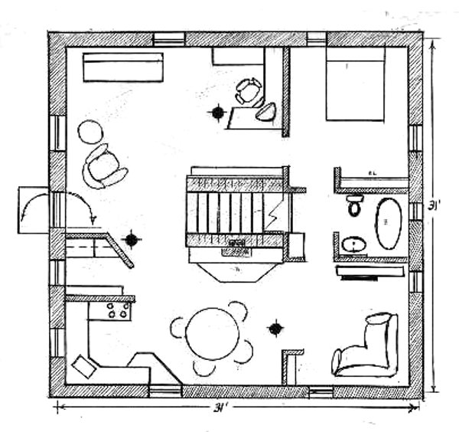
If you are utilizing a 29', 31' or 37' base dimension, you can fit a very comfortable basement apartment under it. This apartment will be served

by the greenhouse, not only as a source of food but also as a source of breathable air.

Grounding. The base, in order to transmit energy properly through the pyramid, must be constructed as a Faraday cage, electrically connected to ground at every point on the foundation. As a practical matter this is very simple. Before you pour concrete base or lay concrete blocks in row-by-row, be sure there is plenty of metal reinforcing rods pounded into the ground, lots of metal shavings, junk pieces, metal auto parts, old hardware mixed in, laid in, poured in with the concrete, so it conducts energy readily to ground. This will also keep "electro-smog" at bay.

Now let's return to Les Brown's narrative.

*********************
Height is measured from the [topmost point of the--ED] apex straight down to the center of the base. The side measurement is the slowing line running from the [top point of the] apex down to the base corner [at the very centerpoint of juncture with the ground or with a solid foundation--ED]. The base measurement is of one side of the base, measured from one centerpoint of the lower corner beam to the next.

Many people are bothered about having read that the base angle must be precisely 51 degrees, 51 minutes, 14 seconds at each base junction, not knowing how to make such miniscule measurements of angles. Don't worry about that!! If you use the above measurements and fasten correctly when you build, these angels will be automatically built in.

For a four-foot pyramid I would advise using steel rods, angle irons, copper pipe, iron pipe or wood. The smaller pyramids can be fabricated easily from good, strong wire such as is used to make coat hangers, or with fairly strong cardboard. Naturally, the wire ones would be open and the cardboard ones closed.

You can make energizers from a number of such cardboard pyramids placed side- by-side. Remember, energy from the points of an energizer is more concentrated than that produced by a single pyramid. The energizer is especially good for experiments in general, or for use as an energized surface on which to stand plants. Once the energizer is constructed, place over the top of it, in contact with the points, a sheet of heavy foil or light-gauge aluminum plate. The energizer is then ready for use. [See Fig. 4].

A pyramid energizer has multiple uses. The one pictured consists of 72 small cardboard pyramids and a top plate of cardboard covered with foil. By placing the top plate on top of the pyramids and orienting the entire energizer to true north, you can use the energy generated for such purposes as mummification, energizing water, or as a beneficial surface on which to place growing plants for outstanding growth.

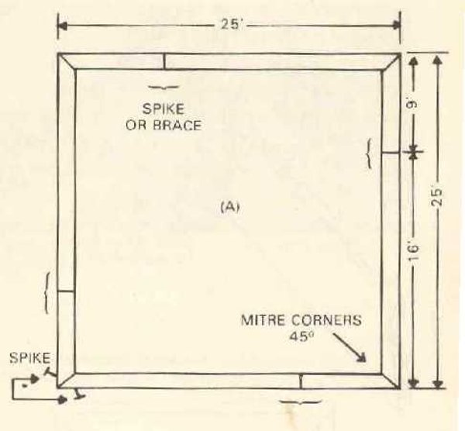
Remember that with all types of pyramids, positioning is all-important. One of the sloping sides must at all times be facing towards magnetic North--nor a corner but the flat face of the pyramid must face MAGNETIC North. Use of a small pocket compass is advised, but one friend of time aligns his by the North Star at night. [That is fine, unless our planet's magnetic North wanders, which it does.--ED] In this respect, a pyramid is like a radio. For maximum performance you must tune it in properly, pointing it right at the transmitter. Similarly, several pyramids oriented to true North and stacked on top of each other will produce increased energy, cell activity and growth.

Pyramids more than four feet at the base need to be made of much stronger materials in general, to prevent any bending, would would negate energy-accumulation. Such pyramids are expensive to build and normally would be erected with some specific use in mind. For instance, consider a 16-foot-high model. Such a size would be ideal in a garden

for encouraging the growth of plants. The very low angle of the sides to the ground would prevent your using some of its square feet, but you would still have nearly 600 square feet at ground level.

Installing a floor at about a seven-foot height and leaving a hole in the middle for access still leaves an extra 80 square feet of growing space. The leaning walls ensure plenty of light all through the pyramid. The larger the base, of course, the larger the second floor will be.

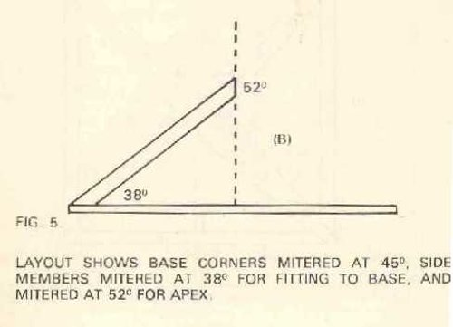

A 16-foot-high pyramid could be built with wood two-by-fours. Two-by-eights leaning sides should be used--set in the thickness of the glazing--with the two-by-fours nailed to the two-by-eights on each face for rigid and glazing support. A pyramid this size can keep a family in vegetables year-round. Eat the vegetables fresh and store the surplus. See Figs. 5, 6 and 7 for guidance in constructing the pyramid.

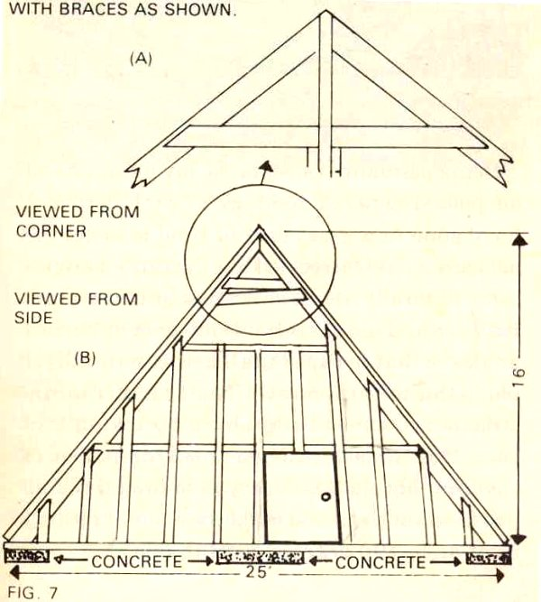
Being permanent structure, pyramids need strong foundations--electrically grounded-- concrete being permeated with metal rods and

waste metal to make it conduct. I have gone to a great deal of trouble to get measurements correct so that the correct angles come naturally. Some care must be taken to cut angles so that the apex fits together naturally. I found this to be the most difficult part of the construction. I solved that problem by taking thin cuts off the wood a little at a time.

One method of ensuring absolute accuracy is to drop a plumb bob from the peak, to make sure that it forms a precise right angle (90 degrees) with the floor. Another is to level the foundation by staking the ground and pouring the foundation or stacking concrete blocks to the leveled string.

A door on each side of the structure will give greatest control over excessive heat in summer. In these photos I have shown large panels for the window sides; however, such construction is up to one's circumstances and ability to garner appropriate glazing. If one only intended to use the pyramid in warm weather, the frame alone would be quite sufficient. However, for those who intend to live under the pyramid, it must be sheathed in glass. Otherwise, one must go through the complete task of re-glazing every few years, if one chooses plastic film or plexiglass that scratches easily.

Winter heating can be achieved by installing warm-water piping around the base of the walls, coupled to a hot water tank similar to one used in a home, plus a circulating pump. A standby heating system of some kind should be provided in case an interruption in electrical supply [to the pump] occurs. Solar panels can be considered, or a heat pump. The drawback with a heat pump system at present is that it also requires electricity to operate. Thus, unless a generator is also supplied for it, such a system cannot serve as backup to a main heating system operating off the same circuit.

Pyramids are natural air circulators; however, to further aid circulation inside I would suggest that floors be built at any height but constructed decking with one-by- fours placed at one-inch intervals to allow air to circulate freely.

With regard to sheathing materials, I would recommend fiberglass or glass. I covered my prototype pyramid with 6 mm plastic, which later proved unable to withstand sunlight or severe weather conditions. I have replaced the plastic with strong, 4 mm fiberglass. Because Canadian winters are so cold, I have also added a layer of plastic four inches inside the fiberglass sheath, thus providing a four-inch air space which

has cut down heat loss dramatically. I'll probably have to add one more "skin" of plastic four inches behind the first plastic insulating skin also. Having an air space between the fiberglass sheathing and the first plastic skin serves as an insulator and forces warm air up through the space between the two layers. I should be able to achieve an even, efficient draft-free heating system, with more practice.

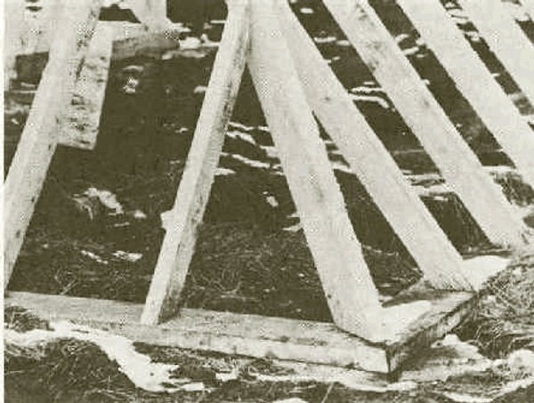

In warm climates glass can be adapted readily as sheathing material, but in severe winter conditions--including hailstorms with hail as large as golf balls--would make utilization of glass impractical. In that case, fiberglass [and an inner insulating layer of plastic] is the ideal covering.

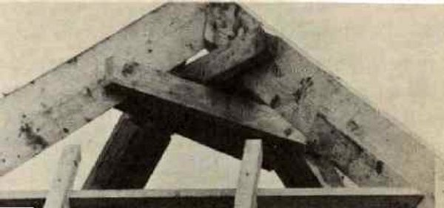
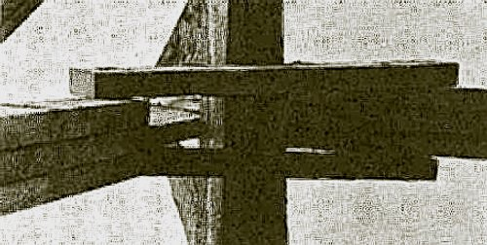

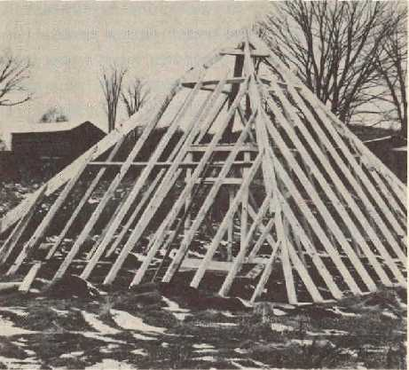

In contrast to winter's cold, one must consider summer heat. To provide adequate ventilation in summer I would suggest incorporating eight opening windows (two on each face) at the pyramid's peak and a set of doors (one on each face) at ground level. Such an arrangement allows ample air circulation and provides the option of closing doors or windows threatened by drafty conditions which are detrimental to plant growth.

It is not necessary to build doors and windows precisely into the slopes of the pyramid as I have done. They can as an alternative be built dormer-style as long as they do not interfere or break into the pyramid's natural lines. Such interference would break the pyramid's energy circuit, resulting in little or no growing performance of plants inside. You can build onto your pyramid such structures as lean-to's, dormers or entrances so long as you do not break the basic outline of the pyramid structure. The same principle applies inside. Floors, stairs or shelves may be added so long as they do not break the continuity of the outside walls.

As mentioned previously, the pyramid's ground floor need not be watered only if it is placed directly on and covers the ground, having no "floor." In the case of a pyramid placed as a roof over a basement apartment, naturally, every floor would require watering.

Your pyramid should not be built near transformers, generators or power lines, for these objects will severely affect its performance. Electrical wiring installed within the pyramid itself, however, will give out a magnetic field which can prove beneficial to the pyramid's performance if you learn how to adapt and which plants to adapt to it. Those desiring to play music to their plants (and I have found this to be beneficial to plant growth) will find the use of tapes more satisfactory than a radio. Radio waves are interfered with inside a pyramid to such an extent that a radio will not perform adequately.

With regard to cost, my 30-foot, prototype pyramid cost approximately $6,000 (1974 Canadian dollars). I did the work on the pyramid myself with the aid of a helper. My cost reflects an allowance for paying the

helper but allots nothing for my labor. Costs have increased to perhaps $8,500 (1978) today for the same materials and labor. Such costs do not include purchase of heating, a water pump or secondary plastic "skins." In addition, fiberglass nor glass frames and sheathing costs were not included. In general, one should plan on a fiberglass model as the optimal choice, with a layer of plastic attached to the inside of the two-by-four studs as your insulating layer also.

Another consideration to make before building your pyramid is the weight that additional first, second or even, third stories will be required to carry. Allow for more than enough support for the first floor as the rule of thumb, because additional support will also be required for second floor and for any succeeding floors beyond the second. And don't forget to add in the weigh of planting boxes and soil. (It should be noted that second floor consideration is not applicable to a 16-foot pyramid heretofore used for illustration. Only when a second floor proves to be of functional value need it be considered in building plans, namely, with a base of 27 feet or more.)

CHAPTER VIII

OTHER USES OF PYRAMIDS

There are so many actual and projected uses for pyramids that I can only touch on a minute fraction of them in this small book. I have used energizers for germinating seeds and then placed the seedlings under wire pyramids. I find this gives extremely good results. On the other hand, I have had relatively poor percentage results from growing seedlings under a wire pyramid from seed. (This is in contradiction to other investigators, who report good results from raising seed under pyramids.) However, when the seedlings are ready to be potted, they are equally successful under or over pyramids. My own objective is to produce more and better food plants. Your own might well be super-flowers. A further use for the pyramid is to place fruits and vegetables under one when you bring them into the house. They will keep better and, as many people claim, taste much more flavorful than normal with such care and treatment.

Water used for growing indoor plants can be placed on an energizer or under a pyramid with extremely beneficial results to the plant when placed in use. Many investigators have reported on this use, claiming that dramatic results can be attained. Some say that such water sprayed on the plants helps control mites and other pests. However, as I say, uses for the pyramid other than for encouraging the propagation of plants are legion.

My wife, who suffered from migraine headaches, had a severe attack for a week; and during that time she took more than an abundant supply of pills, which proved of no benefit. She pladed a pyramid on her head in the early hours of the night, and in about 20 minutes had been relieved of all pain. She said nothing of this to me, but two weeks later suffered another headache. Instead of suffering for a lengthy period, she used the pyramid again, and without the use of pills the headache vanished again in about the same length of time. She told me about this second episode. About a week later she suffered an ordinary headache and repeated the performance, with the same result. She now has gone three years with no headaches at all. Around this time, I had been working all day in the hot sun, and the back of my neck became quite painful. I tried placing a small pyramid on the back of my neck while I sat still for a while. It produced the same relieving results for me because I believe it increases blood circulation to the affected part.

After about ten minutes I could feel the pain being drawn out upwards. At the same time my head felt cold on top, not cold to the touch, but simply felt cold to me. I mentioned this to my wife, and she said she had had the same sensations of coldness but was waiting for me to remark about them first. I am not suggesting that this treatment will do the same for everyone, but merely mentioning that it worked for us. The pyramid must work in approximately the same way that reflexology works, by increasing electrical conductivity of the cells.

The elderly mother of a friend of mine, her hands badly crippled with arthritis, was persuaded to place her hand on an energizer. A wire pyramid was put over both hand and energizer for one hour. She continued this treatment for a few days, experiencing a diminution of pain and a loosening of her fingers each time. Before she returned to her home in England she actually sat and played the organ. She played haltingly and rustily, it is true, but she had been unable to play at all for several years prior to using the pyramid. Significantly (her pyramid was stolen at the London Airport), her hands returned to their crippled state shortly after she returned to England.

We also find that when we are feeling low and depressed, my wife and I sit for an hour or so, each with a small pyramid on our head, facing north, our depression lifts and we feel quite rejuvenated. My wife and I regularly drink pyramid-treated water. If we are feeling low we have a snifter of pyramid water and in a short time we feel a marked lift. On the other hand, if we find ourselves in what used to be described as a choleric state and sit with the pyramid on our head--but facing south--our irritability rapidly leaves and is replaced by a calm. Naturally, that would never work if we used the pyramid as a bandaid and a way of avoiding dealing with problems of the day, first.

A prominent acquaintance of mine who does not wish to be named always drives with a pyramid under his car seat. He claims he feels less "bushed" after a long drive than he did before he did so.

Many investigators have found that by putting a pyramid or an energizer over or under their beds, they experience better and more refreshing sleep, some of them claiming they need far less sleep than they required before utilizing a pyramid for this purpose.

Dogs and cats seem to find the use of pyramids for a similar purpose quite congenial. The cat pet of a friend of ours regularly is found curled up under a wire pyramid, seeming to prefer sleeping under it than anywhere else.

The real keynote when trying these pyramid experiments is persistence. As with many other experiences, pyramids do not always "work" the first time you apply one to a situation, and a person must "stay with it" and make subtle corrections until the desired results are obtained.

Putting energized water into a vase containing tulips caused them to last for about three and a half weeks. Not only did they last this phenomenal time, but they grew about nine inches in the meantime! I have never before seen flowers grow after having been cut.

Many people claim that insect stings stop itching after the application of energized water; this has been our own experience. In another instance I had a nasty cut on my hand. Immediately after washing it with pyramid water, the pain stopped and with healing, I had no scar. The cut also healed much more quickly than is "normal" for me.

This book has been an informal and easy presentation of what I have found in experimenting with pyramids. If it inspires you to experiment yourself, I would be delighted. If enough of us are seen to be experimenting, perhaps we shall be able to awaken a few of our dreadnought politicians to a sense of urgency and experimentation themselves. Who knows?

APPENDICES

EXPERIMENTAL RECORDS AND TIPS

In experimenting with pyramids, or with growing plants, or tracking costs and labor, you will find it extremely helpful to keep accurate records--a journal--to be able to return to and observe your own progress and refer back during problem times. Here are two simple charts you can copy, to track your experiments with plants and pyramid-power.

In addition to the sample charts this appendix contains tips on procedures to help you attain the best results in your experiments. As mentioned in the body of the book, learning from your own experience is the best way to go. Once your experiments are underway and you persist in entering data in your charts, it is worthwhile to have on hand a true Journal for summarizing your findings. Even in twelve months' time you will compile a great deal of invaluable knowledge and experience. Don't lose it by failing to record it.

PLANTING TIPS

To achieve the best results with plants, a few simple practices should become part of your routine.

First, never give seeds or cuttings cold water; it has a shocking, damaging effect. Let the water assume the temperature of the environment in which the plants are growing before it is used. In addition, water energized and stored over a pyramid generator will improve growth substantially.

Secondly, it is best to start cuttings and seedlings in tin cans for a better root system than normally is achieved by planting in soil alone. The metal in the cans provides a boost to plant growth. A hole in the cottom of the can will provide proper drainage. If you do choose to plant in pots, it is helpful tp place bits of metal in the bottom of the pots to aid growth. It is important, however, not to plug the pot's drainage hole.

Also, when you plant in a permanent position outdoors, it is helpful to lay the plant roots toward the north inte hole or, preferably, trench, in which the plant is positioned. Never plant with roots pointing toward the east or west. Again, placing pieces of metal all around the plants will prove tremendously beneficial to growth.

PLANTING MEDIA

SEEDS--Keeping in mind the use of ingredients Mother Nature provided, a simple, effective mixture in which to germinate seeds is this suggestion: 1 part soil, 1 part leaf mold (hard wood) 1 part coarse sand.

CUTTINGS--Coarse, damp sand is an effective growth medium for cuttings. The cuttings should not be watered further until they begin to grow. Rather, if they are placed over but not touching a water source, they will send roots down toward the water.

CONTROLS--One final tip, and also one of the most important when experimentation is involved, is to set up a control against which to validate results achieved in your experiments. A control is a "normal" used for comparison to experimental results. Setting up a control involves setting up the subject of the experiment and apparatus in an identical manner to that used on experimental "trials" except that the control is placed under "normal conditions." In this case, the variable being measured is effects of the pyramid. All conditions, therefore, should be the same except that the control is placed outside and away from a pyramid. The results of the experiment will thus be due to the only variable involved, the pyramid itself. A control lends validity to any experiment.

PREFACE -- Everything I need to know about life, I learned from Noah's Ark ...

* One: Don't miss the boat.
* Two: Remember that we are all in the same boat.
* Three: Plan ahead. It wasn't raining when Noah built the Ark.
* Four: Stay fit. When you're 600 years old, someone may ask you to do something really big.
* Five: Don't listen to critics; just get on with the job that needs to be done.
* Six: Build your future on high ground.
* Seven: For safety's sake, travel in pairs.
* Eight: Speed isn't always an advantage. The snails were on board with the cheetahs.
* Nine: When you're stressed, float a while.
* Ten: Remember, the Ark was built by amateurs; the Titanic by professionals.
* Eleven: No matter the storm, when you are with God, there's always a rainbow waiting.

